DAY -2

ZECPATH AI

Project Prepared By Suhail TP

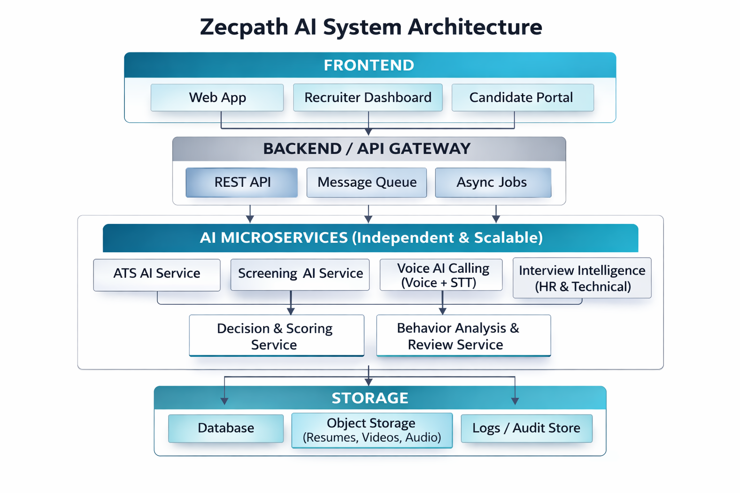
Data flow diagram
(Backend ↔ AI ↔ Storage)
Storage Layer
- Centralized repository for structured data (Database).
- Unstructured files (Object Storage for resumes and media).
- System tracking (Logs / Audit Store).
Frontend Layer
- Composed of a Web App
- Recruiter Dashboard
- Candidate Portal to handle various user interactions
AI Microservices Layer
- ATS AI Service
- Screening AI Service
- Interview Intelligence AI Service
- Behaviour Analysis
- Decision Scoring
- Notification and Communication AI

Backend / API Gateway
- Acts as the central orchestrator, managing requests via REST APIs and delegating heavy tasks through a Message Queue for asynchronous jobs.
- Receive Data
- Store and Retrieve
- Trigger AI Processing
- Manage Workflow

AI Microservice Specifications

